UNIT-V
Governance and Billing: Organizational readiness and change management in the cloud age, Data Security in the cloud, legal issues in cloud computing.
Managing AWS billing: Free tier, Pay-per-Use, Create a budget alert to keep track your AWS bill, Alternative cloud providers.

Governance and Billing: Organizational Readiness
Organizational Readiness
Organizational readiness refers to how prepared a company’s people, processes, and culture are to handle a major transition, such as moving to the cloud. Technology is often the easy part; changing the organization is the challenge.
The Psychology of Resistance: FUD
The primary barrier to cloud adoption is not technical—it is human. Employees often experience FUD:
- F: Fear (Fear of losing their job or being unable to learn new systems).
- U: Uncertainty (Not knowing how the future state of the company will look).
- D: Doubt (Doubting if the new technology will actually work better than the old one).
Why People Resist Change
- Comfort Zones: Employees are comfortable in their current roles and are used to established workflows.
- Established Expectations: They clearly understand what management currently expects from them.
- Disruption: Large-scale changes—such as shifts in job roles, business processes, or company structure—create discomfort and push people out of their "safe" stable environments.

Change Management
The Role of Leadership in Change Management
Leadership is responsible for bridging the gap between the old way of working and the new cloud-integrated vision.
- Clear Communication: Leaders must explicitly explain why the change is happening. Without a clear "why," employees cannot accept the new vision.
- Cultural Realignment: Leadership must introduce new values and reward systems that match the company’s new direction.
- Skill Development: Providing training is essential to replace "Fear" with "Competence."
- The 60% Failure Rule: Studies indicate that 60% of change projects fail. This failure is rarely due to the technology; it is almost always due to "people-related issues," such as failing to change mindsets or corporate culture.

Organizational Preferences: Private Cloud vs. Public Cloud
A survey by Forrester highlighted why large, established companies often hesitate to move entirely to public clouds and instead prefer Private Clouds.
Reason A: Protecting Current Investments
- Large companies have spent millions of dollars over decades on physical hardware, data centers, and specialized on-premise software.
- They prefer private clouds because they allow the company to leverage their existing infrastructure while still gaining some cloud-like benefits (virtualization, automation).
Reason B: Managing Security Risks
- Data Sovereignty: Companies often feel safer keeping sensitive data "within the company walls."
- Control: In a private cloud, the organization has total control over the security protocols, firewalls, and physical access to the servers, which reduces the perceived risk associated with third-party providers.

Drivers For Changes: A Framework to Comprehend the Competitive Environment
Organizations do not change in a vacuum; they change because of specific "Drivers." This framework helps businesses analyze five key areas to make smarter decisions and plan short-term and long-term strategies.
The Framework. The five driving factors for change encapsulated by the framework are:
- Economic (global and local, external and internal)
- Legal, political, and regulatory compliance
- Environmental (industry structure and trends)
- Technology developments and innovation
- Sociocultural (markets and customers)
Organizations must constantly adapt to stay competitive. To understand and prepare for changes, businesses analyze five key drivers that impact their environment. This approach helps them make smarter decisions and plan both short- and long-term strategies.
These five drivers are:
Economic Drivers (Global & Local)
Economic factors directly influence business performance and resource allocation.
- The Impact: Events like the 2008 financial crisis show how global shifts affect every business.
- Common Challenges: Shrinking market share, lower profits, rising competition, and the constant need for cost-cutting measures.
- The "More with Less" Rule: Managers are increasingly expected to deliver higher results with fewer resources.
- Strategic Questions:
    - Is capital easily available?
    - What is the Total Cost of Ownership (TCO)?
    - "Build vs. Buy": Should we create a custom solution or buy a SaaS product?
2. Legal, Political, and Regulatory Compliance
Governance must ensure the company stays within the boundaries of the law to protect its reputation.
- Risk Management: Failure to comply with political guidelines or regulations leads to legal penalties and permanent damage to the brand image.
- Strategic Questions: * What are the specific legal requirements for our data?
  - What are the consequences of non-compliance?
  - Are there global political issues (e.g., trade wars or data sovereignty laws) that impact us?
3. Environmental Drivers (Industry Structure and Trends)
This refers to sustainability and the physical environment in which the industry operates.
- Green Initiatives: Companies are under pressure to reduce their carbon footprint and meet health and safety standards.
- The Cloud Connection: IT and cloud computing are seen as tools to help organizations operate more sustainably (e.g., using "Green Data Centers").
- Strategic Questions: * How is global warming affecting our supply chain or operations?
  - Can cloud technology help us reach our environmental goals?
4. Technology Developments and Innovation
Innovation is often the most powerful driver of change in the modern era.
- Disruptors: Technologies like AI (Artificial Intelligence), IoT (Internet of Things), Cloud Computing, and Blockchain transform business operations.
- Adaptability: Companies must remain "future-proof." Their current applications must be able to work with future cloud infrastructures.
- Strategic Questions: * Who are the current leaders in cloud technology?
  - Can our apps adapt in real-time to technical issues like low bandwidth?
5. Sociocultural Drivers (Markets and Customers)
This focuses on the "Human Element"—how society and customer behaviors shift over time.
- Customer Expectations: Trends and demographics change how people want to interact with a brand.
- User Experience: Technology is no longer just a tool; it is a way to improve the customer's life.
- Strategic Questions: * Is cloud computing actually making life better for our users, or is it just hype?
  - What are the new demographic trends (e.g., younger users preferring mobile-first apps)?

Creating a Winning Environment
In any organization, change is difficult because there is often a Perception Gap. While senior leaders may feel the shift to the cloud is urgent and strategic, employees may view it as an unnecessary disruption. To bridge this gap, leadership must follow a structured approach to foster a positive environment.
To successfully create a positive environment for change, top leaders need to do the following:
To successfully transition the workforce, top leaders must execute the following five actions:
- Define the New Direction: Leaders must clearly articulate the "North Star"—where the organization is heading in the cloud age. If the destination is unclear, employees cannot align their efforts.
- Emphasize Urgency: It is not enough to say change is "good"; leaders must explain why it is urgent. They must answer the question: "Why does this need to happen right now?"
- Perform a Dual-Risk Explanation: Transparency is key. Leaders must honestly explain two types of risks:
  - Risk of the Status Quo: What happens to the company if we don't change? (e.g., losing market share, becoming obsolete).
  - Risk of the Change: What could go wrong during the transition? Acknowledging these risks builds trust with employees.
- Clarify New Roles and Expectations: One of the biggest fears for employees is the unknown. Management must explicitly define:
  - What will the new job roles look like?
  - What specific behaviors or technical skills are now expected from each individual?
- Highlight the Rewards: Change must be seen as a "Win-Win." Leadership should highlight:
  - Company Benefits: Increased competitiveness and sustainability.
  - Employee Benefits: New skill sets (upskilling), career growth, and more efficient tools.
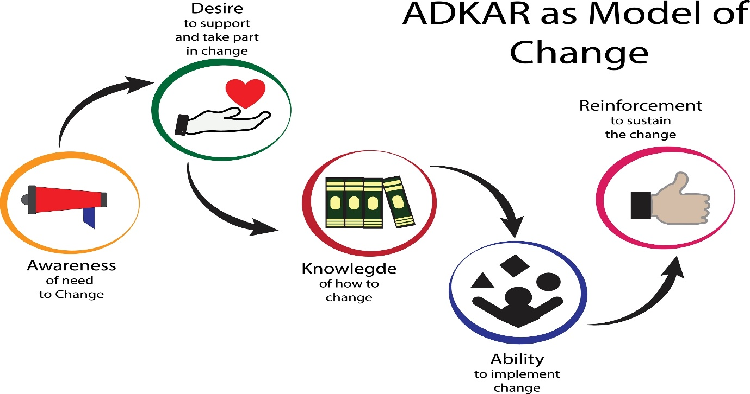

Data Security in the cloud
The Evolution of Cloud Security
1. Defining the Digital "Lock-and-Key"
Data security is the technical and administrative process of safeguarding digital assets from unauthorized access, corruption, or theft.
- Traditional vs. Cloud: In the physical world, security meant "four walls and a vault." In the cloud, the vault is encryption.
- The Container Concept: Think of data as being placed in a secure, encrypted container. Only those with the mathematically linked "key" (authorized users) can view the contents, ensuring that even if the container is stolen, the data inside is useless to the thief.
2. The Shift to "De-perimeterization"
- The Old Way: Security used to focus on the Network Perimeter (firewalls and data center gates).
- The Cloud Reality: Data is no longer stationary; it flows across devices, apps, and countries. Therefore, the perimeter has disappeared.
- This group of IT leaders argued that security must be Data-Centric. Instead of building a wall around the network, we must build a wall around each individual piece of data.

The Four Levels of Data Object Security
This model treats every file as a "Data Object" protected by concentric layers.
- Level 1: Transmission Security (Data in Motion)
  - Goal: Protect data as it travels from your computer to the cloud provider.
Uses protocols like SSL/TLS. It prevents "Man-in-the-Middle" attacks where a hacker intercepts your connection to steal information while it's being uploaded.
- Level 2: Basic Access Control (The Gatekeeper)
  - Goal: Verify who is trying to open the file.
Uses Identity Management (logins/passwords). However, the content inside is not encrypted. If a hacker bypasses the login, the data is wide open.
- Level 3: Content-Centric Security (The Safe)
  - Goal: Protect the data even if the "gatekeeper" fails.
Adds Full Encryption to the file's contents. Even if an unauthorized person gains access to the file, they cannot read it without the decryption key.
- Level 4: Comprehensive Rights Management (The Controller)
  - Goal: Control what happens after the file is opened.
Uses Digital Rights Management (DRM). It restricts actions like "Copy/Paste," "Print," or "Forward," ensuring the data stays within the intended hands even after it has been accessed.

Identity, Reputation, and User-Centricity
1. Identity as the New Perimeter
In the cloud, your "Identity" is the only thing that proves you have the right to access data. Security systems now use identity as the primary backbone for all permissions.
2. Reputation-Based Access
Much like an eBay seller's rating, digital identities can have a Reputation Score.
If a user’s identity is verified by multiple trusted sources and they have a history of "safe" behavior, they are granted higher trust. If their score is low, the system may require extra authentication (like MFA) before allowing access.
3. User-Centric Philosophy
- Control: The trend is moving away from companies owning your identity (Enterprise-centric) to User-owned identities.
- Privacy: Users should have the power to decide which "claims" (attributes like age or email) they share with a cloud service, ensuring minimal data exposure.

Legal Challenges in the Cloud
1. Cross-Border & Jurisdictional Hurdles
- Statelessness: Since cloud servers are spread globally, data is "stateless." This leads to Conflict of Laws—if a dispute happens, it is legally difficult to determine if Indian, US, or EU law applies.
- Data Sovereignty: Many countries (like the EU with GDPR) have "Localization" laws. If a cloud provider moves your data to a server in a country with weaker laws, you—the user—might be legally liable for a compliance breach.
2. The Supply Chain & Contractual Privity
- The "Chain" Problem: A Cloud Provider often hires a sub-contractor for storage.
- Liability Disclaimer: Providers often use "Service Agreements" to state they are not responsible for the failures of their sub-contractors.
- Privity: Because you only have a contract with the Main Provider, you have no "Privity" (legal standing) to sue the sub-contractor directly if they lose your data.
3. Privacy in Multi-Tenancy
- Shared Hardware: In the cloud, your data is "neighbors" with others on the same physical disk.
- The Legal Risk: Privacy isn't just a policy; it’s a technical requirement. If the Virtualization Layer (the software separating users) fails, it's a legal breach of privacy, yet the user has almost no way to audit this technical integrity.
4. Service Level Agreements (SLAs)
- Take-it-or-Leave-it: Most cloud contracts are "Contracts of Adhesion." They are non-negotiable "click-through" terms.
- Limited Liability: Most SLAs state that if the provider loses your data, they are only liable for the cost of the service (e.g., $50), not the value of the data lost (e.g., $1M).
5. Exit, Portability, and Interoperability
- The "Lock-in" Risk: If you want to leave a provider, do they have a legal obligation to give you your data in a usable format?
- Extraction Rights: Without clear "Extraction Rights" in the contract, a provider could technically return your data in a "garbage" format that no other system can read, effectively holding your business hostage.
6. The Hacking & "Lost Profits" Dilemma
- The Big Question: If a vendor's poor security leads to a hack, can you sue for Consequential Damages (money you lost because your business stopped running)?
- The Current Reality: Most cloud providers explicitly exclude "Lost Profits" in their contracts. This shifts the entire financial risk of a cyber-attack onto the customer, regardless of who was at fault.

Managing AWS billing
I. Understanding AWS Billing: The Pay-As-You-Go Model
AWS billing is designed to be similar to a utility bill (like electricity). You are only charged for what you actually use.
- Billing Cycle: Services are invoiced on a monthly basis.
- Public Pricing: Pricing for every service is transparent and available online.
- Planning Tools: The AWS Pricing Calculator (calculator.aws/) can be used to estimate the monthly costs of a planned setup before deployment.
Calculation Metrics:
  - Time-based: Paying for the duration a virtual machine is running or a load balancer is active.
  - Capacity-based: Paying for the amount of storage used in an object store.
  - Quantity-based: Paying for the specific number of running resources.

II. The AWS Free Tier
The Free Tier is designed to allow new users to experiment and gain experience with AWS services at no cost for the first 6 months after signing up.
1. Key Inclusions (6-Month Period)
Service Type | Free Tier Inclusion
Compute (EC2) | 750 hours/month of a small VM (Linux or Windows). You can run one VM for a month or 750 VMs for one hour.
Load Balancer | 750 hours/month of a classic or application load balancer.
S3 Storage | 5 GB of Standard object storage.
RDS (Database) | 750 hours of a small relational database (db.t2.micro) with 20 GB of storage + backup.
2. "Free Forever" Services
Even after the initial 6-month trial ends, some services remain free up to certain limits.
- Example: The first 25 GB of data stored on a DynamoDB (NoSQL) database is free forever.
3. Important Caution
If you exceed the specified Free Tier limits, AWS will start charging you for the consumed resources without further notice.

III. Billing Categories and Examples
AWS uses different metrics to calculate costs depending on the nature of the service.
Type | Example | Notes
Time-based | EC2 (per second), Load Balancer (per hour) | Ideal for short-term workloads.
Data-based | S3 (per GB stored or transferred) | Watch for costs associated with large data transfers.
Request-based | API Gateway or Lambda (per request) | Highly cost-effective for serverless applications.

IV. Benefits of the Pay-As-You-Go Model
- No Upfront Investment: You do not need to buy expensive hardware/infrastructure in advance.
- On-Demand Scalability: You can spin up or shut down servers at any time based on need.
- Cost Efficiency: You only pay for exact usage (per second, hour, GB, or request).
- Budget-Friendly Fault Tolerance: You can split services for high availability (redundancy) without incurring massive extra costs.

V. Comparing the "Big Three" Cloud Providers
While AWS, Microsoft Azure, and Google Cloud Platform (GCP) all share a global infrastructure, IaaS offerings, and pay-as-you-go models, they have distinct focuses:
- AWS (Amazon Web Services): The market leader with the most extensive portfolio. Focused on solving internet-scale problems with innovative, mostly open-source technologies. It is considered the most mature and powerful platform.
- Microsoft Azure: Focused on providing Microsoft’s technology stack in the cloud. It has recently expanded heavily into web-centric and open-source tech to catch up with Amazon’s market share.
- Google Cloud Platform (GCP): Best for developers building sophisticated distributed systems. It is more focused on "cloud-native" applications rather than migrating existing locally hosted applications.

VI. Cost Management: Creating Budget Alerts
Because pay-per-use billing is not always 100% foreseeable, it is critical to set up alerts to avoid unexpected charges.
Step A: Configure Free Tier Usage Alerts
- Open Billing Preferences in the AWS console.
- Enable "Receive Free Tier Usage Alerts."
- Enter your email address and click Save preferences.
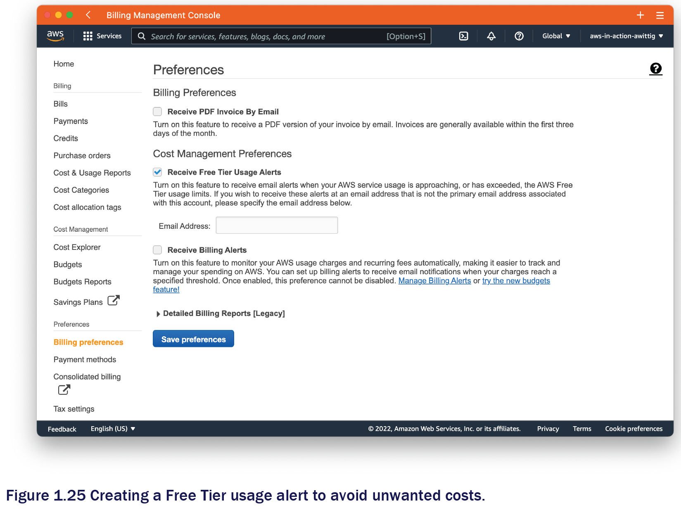
Step B: Create a Cost Budget
- Open Budgets in the Management Console and click Create budget.
- Select Cost budget and click Next.
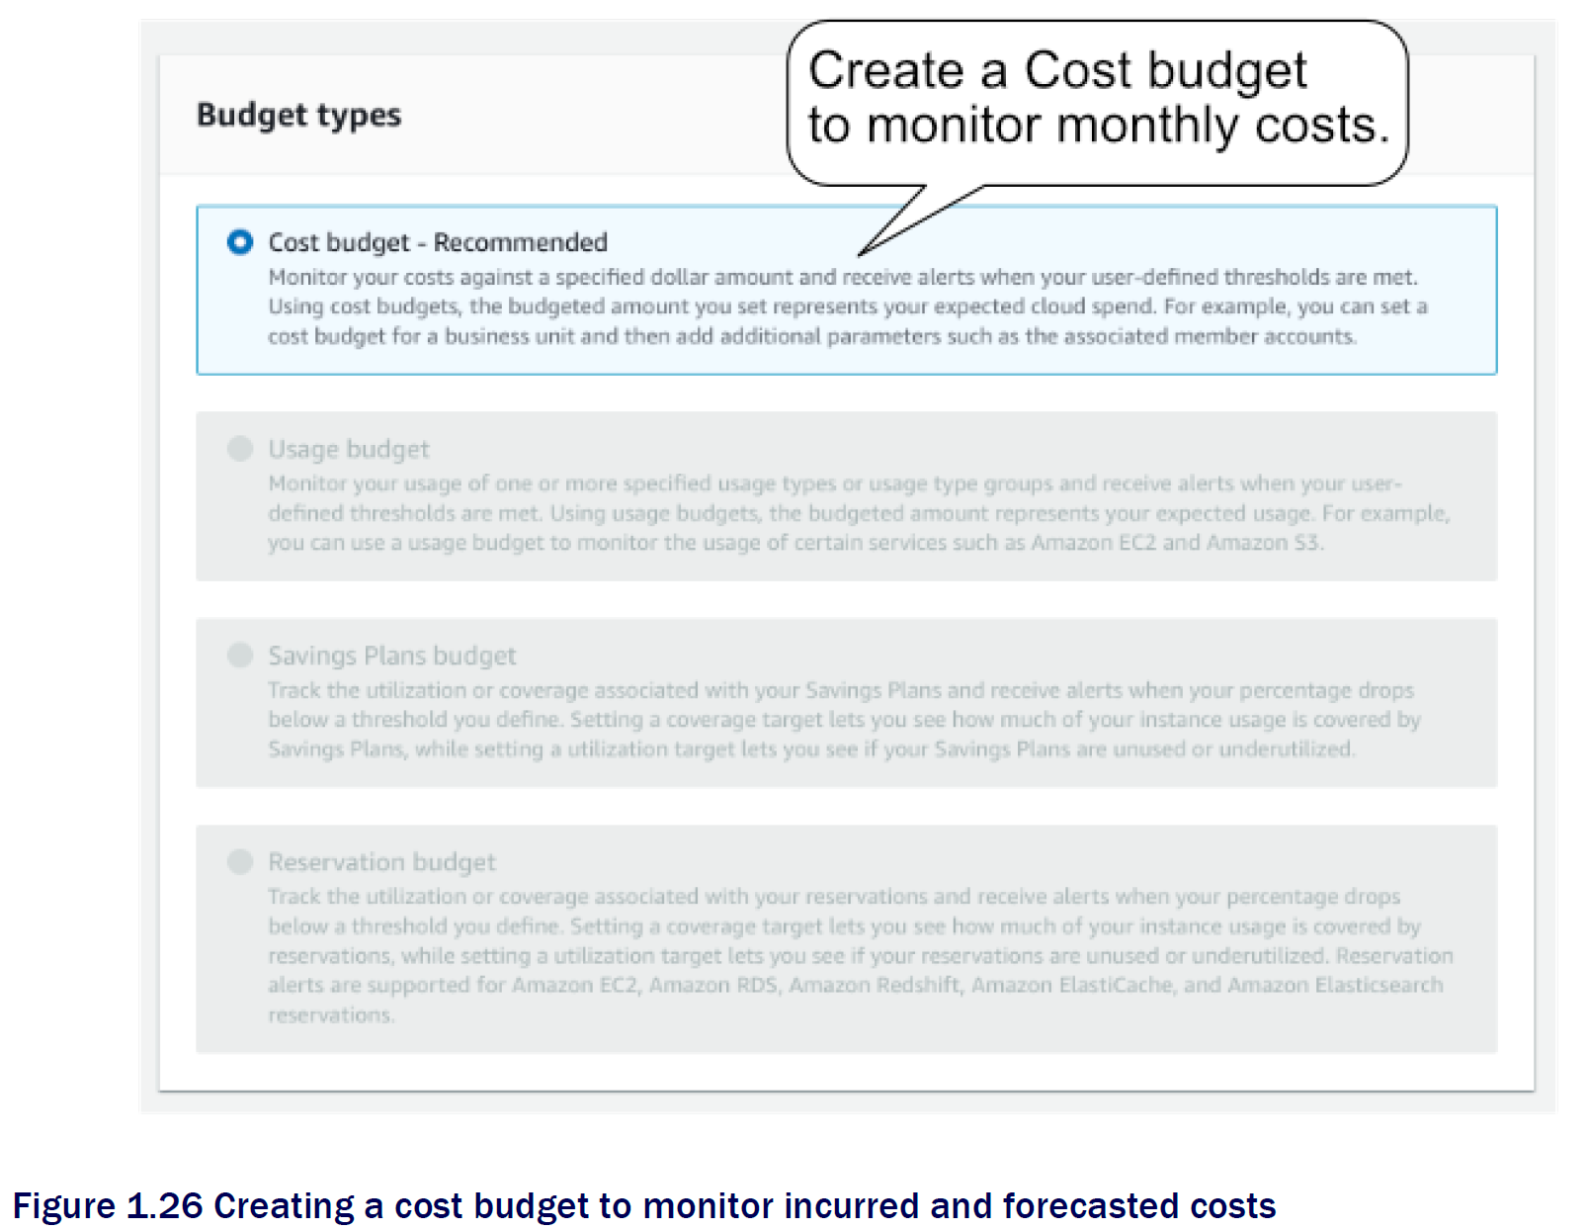
- Configure Budget:
  - Period: Monthly / Type: Recurring.
  - Start Month: Current month/year.
  - Budgeting Method: Fixed.
  - Amount: Type 5 (to set a $5 USD limit).
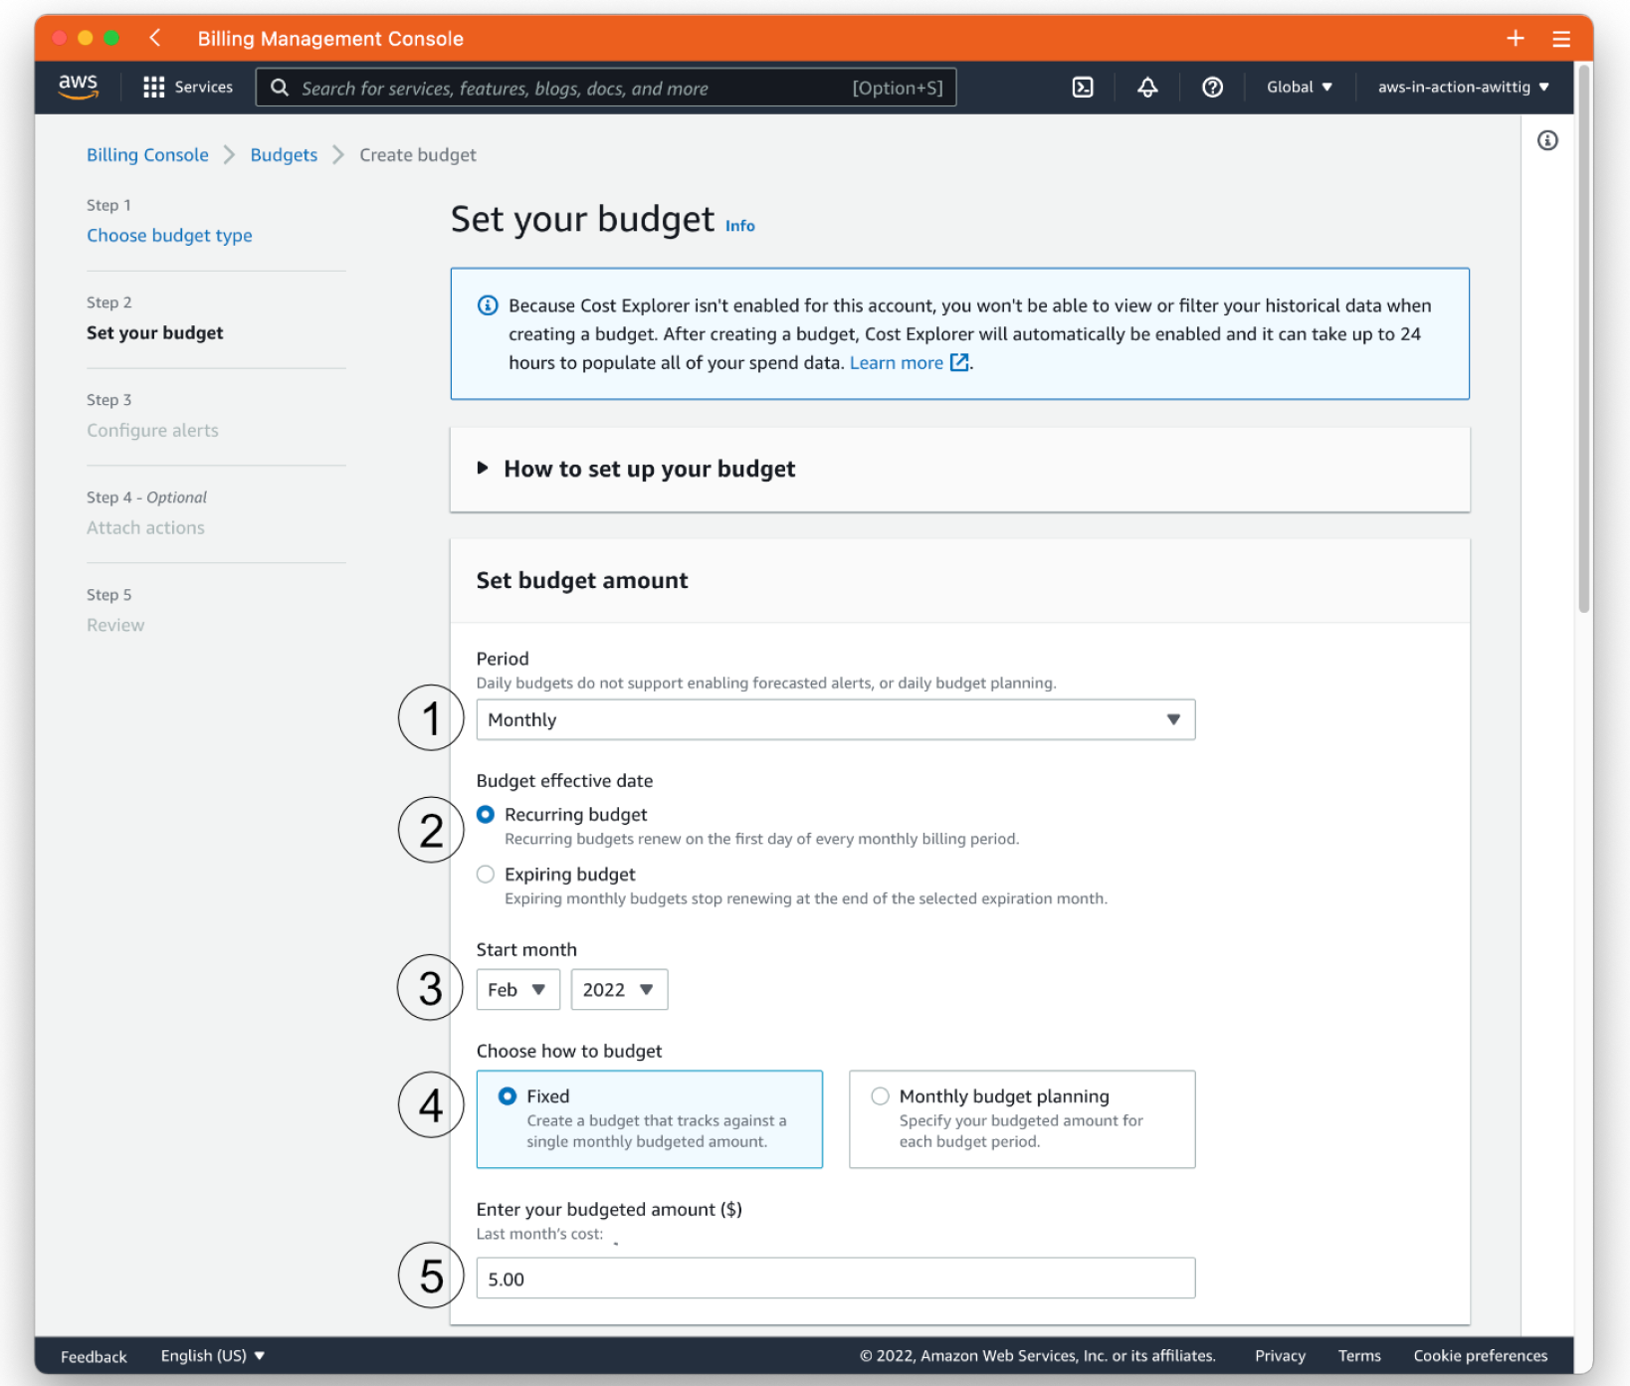
- Set Alert Thresholds:
  - Threshold 1 (Actual): Set to 100% of the budgeted amount. Enter email. (Notifies you when current costs hit $5).
  - Threshold 2 (Forecasted): Set to 100% of the budgeted amount. Enter email. (Notifies you if AWS predicts you will hit $5 by the end of the month).
  - 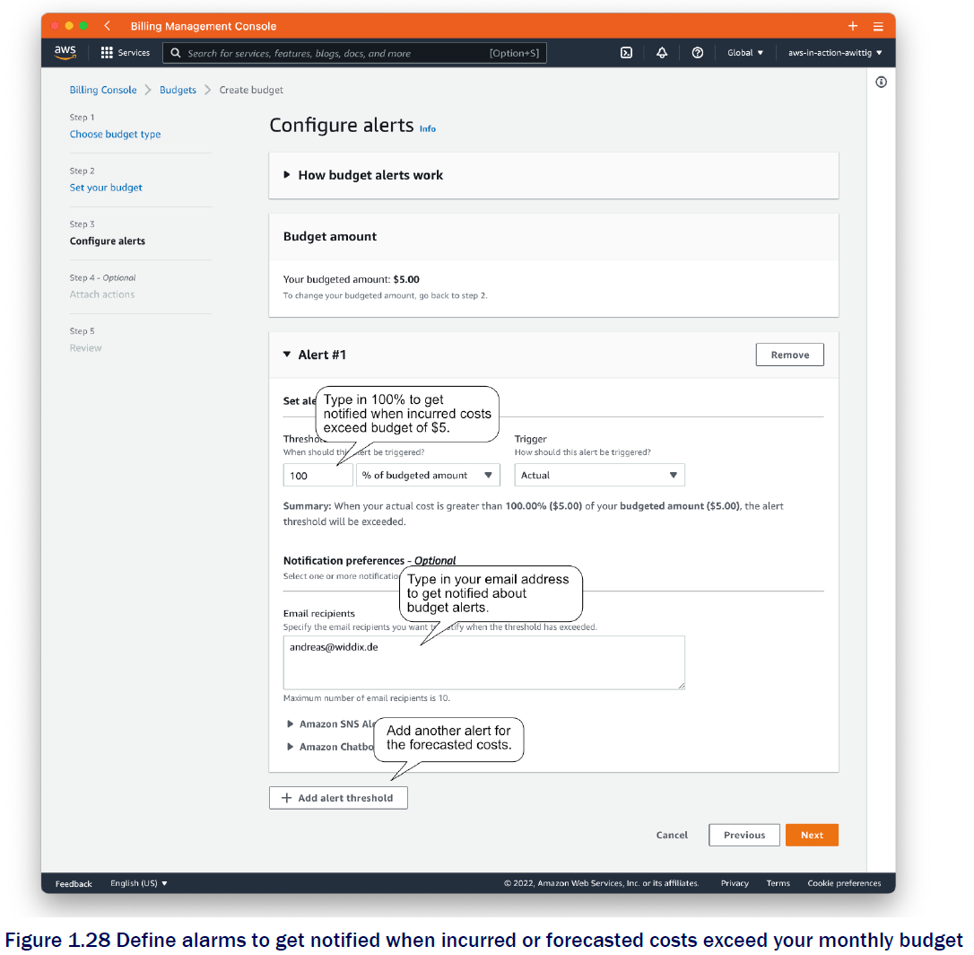
- Review and Create budget.

Alternative cloud providers
Feature | AWS (Amazon Web Services) | Microsoft Azure | Google Cloud Platform (GCP)
Market Identity | The "Pioneer" with the most extensive and mature toolset. | The "Enterprise Choice," best for companies already using Microsoft software. | The "Data & AI Specialist," known for high-performance computing and open-source.
Core Compute | EC2 (Elastic Compute Cloud). Highly customizable instances with the widest range of CPU/RAM configurations. | Virtual Machines. Strongest integration with Windows Server and Active Directory. | Compute Engine. Known for the fastest boot times and "Custom Machine Types" (choose exact CPU/RAM).
Serverless Architecture | AWS Lambda: The industry standard for event-driven functions. | Azure Functions: Excellent for connecting with .NET and enterprise workflows. | Cloud Functions: Deeply integrated with Firebase and Google’s data tools.
Object Storage | S3 (Simple Storage Service): Offers 11 nines (99.999999999%) of durability and complex lifecycle policies. | Blob Storage: Highly scalable for unstructured data; integrated with Azure Data Lake. | Cloud Storage: Features "Multi-regional" storage with very high availability for global apps.
Database Specialization | DynamoDB: High-performance NoSQL. Aurora: High-end relational database. | Cosmos DB: A "globally distributed" multi-model database with very low latency. | BigQuery: A serverless, highly scalable data warehouse for massive analytics.
Networking & Content Delivery | CloudFront: Massive global edge network. Direct Connect: Private physical link to AWS. | ExpressRoute: High-speed private connection, often preferred by banks/large firms. | Cloud CDN: Leverages Google’s own private global fiber-optic network.
Kubernetes & Containers | EKS: Robust and secure. Fargate: Allows running containers without managing servers. | AKS: Simplifies Kubernetes management; very popular for hybrid-cloud setups. | GKE: The "gold standard." Since Google invented Kubernetes, GKE is the most advanced.
AI & Machine Learning | SageMaker: A complete "factory" for building, training, and deploying ML models. | Azure AI Gallery: Focuses on ready-to-use "Cognitive Services" (Vision, Speech, Language). | Vertex AI / TensorFlow: Best-in-class for deep learning and high-end data science.
Hybrid Cloud Support | AWS Outposts: Brings AWS hardware to your local data center. | Azure Arc: The leader in hybrid cloud; manage on-premise and cloud servers together. | Anthos: Allows you to run and manage apps across GCP, AWS, and Azure.
- Why choose AWS?
  - It has the most features and the largest community. If a new technology exists, AWS usually has a service for it first.
  - Best for: High-scale startups and general-purpose cloud needs.
- Why choose Azure?
  - It offers a "seamless" transition for companies using Microsoft 365, Teams, and SQL Server. You can often use existing licenses to get discounts (Azure Hybrid Benefit).
  - Best for: Large established corporations and government entities.
- Why choose GCP?
  - Google focuses on efficiency. Their "Sustained Use Discounts" automatically lower your bill if you run a server all month. They lead in Big Data and Machine Learning.
  - Best for: Data-heavy applications, AI research, and containerized (Kubernetes) apps.

